Synchronous Generator Control System for Microgrids

**Introduction:** With the recent progress in the field of power electronics, renewable energy resources and cheaper computing cost has made the power generation so easily available that any household can generate its own power. This phenomenon of captive power generation is more ubiquitous in the third world community, where the power distribution system has not even reached or function properly. The increasing penetration of renewable energy and inverter at cheaper cost is leading to islanding and creating small grid and have benefits as well as challenges.

Our effort is aimed to model the captive power generation process using the standard synchronous machine and attempt to model control system for voltage and frequency control. Along with the individual generator control, the attempt is also made to model the control system to synchronize the two generator which is necessary for parallel operation of two generator running parallelly to share the load.

**Problem definition:** The problem is aimed to model and simulate

1. Two independently running generator.
2. Voltage and frequency control system
3. Control system for phase control and synchronize the two generators.

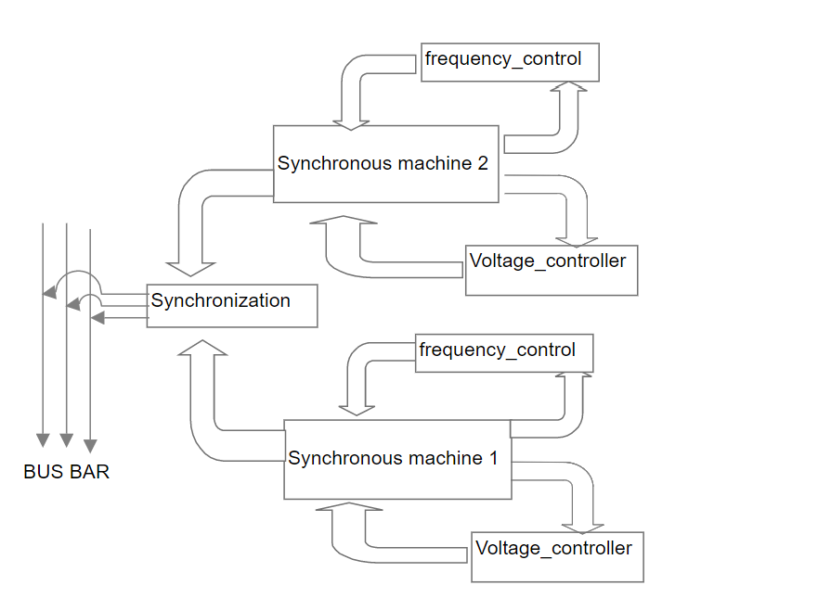

**Approach:** We started with a three-phase machine and configured it for the alternator mode. The voltage of the alternator is controlled by it rotor voltage, which is also called the field voltage. Any change in field voltage reflects change in flux linkage and as per Faraday’s law of electromagnetism, it affects the voltage produced by stator winding. The refence voltage is set and calibrated as per machine. The PI controller is used for stabilizing the voltage, whenever it fluctuated from its reference value. Likewise, the frequency is sampled, calibrated and controlled by another PI controller.

The tool that is used for the purpose of modeling and simulation is

* Simscape- power system
* Simulink
* Matlab functions
* **Formal Models:** The center of the whole modelling is ‘IEEE standard 1110-2002’, which has standardized the dynamic model of the three-phase synchronous machine. In this standard, the modelling of electrical machines is based in the direct and quadrature axis for simplicity reasons. The transformation is reducing the three AC quantities into two DC quantities and is in this way reducing the amount of effort in further calculations. Robert H. Park developed this transformation in 1929 and is now the standard approach in the study of electrical machines. The machine can be used either in the form of generator or motor based on its configuration. Mechanical system of machine can be modelled as

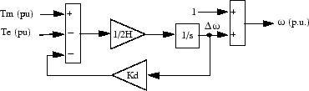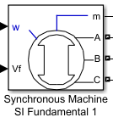 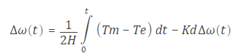 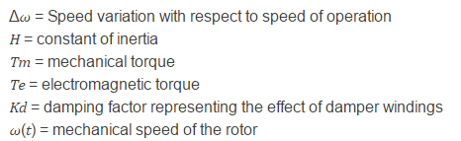

Electrical model of generator: To understand the electrical model , we first need to understand the Robert H. Park ‘s transformation, which reduce the three AC quantities into two DC quantities.

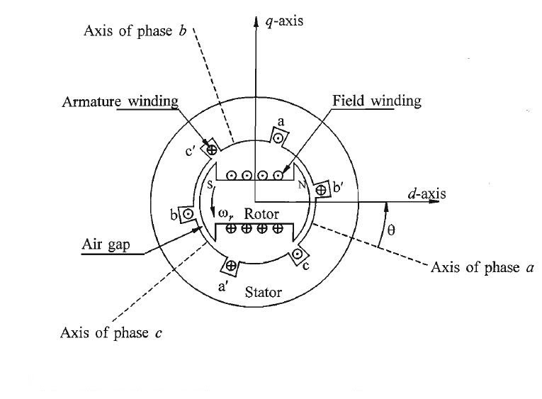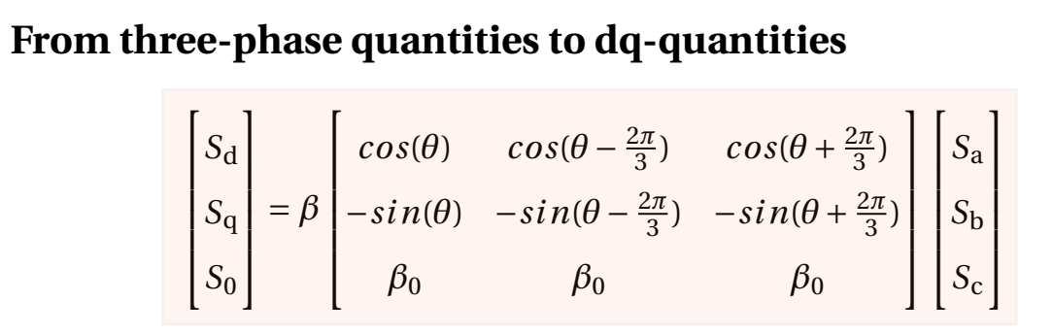

*Where S* is representing the quantity being transformed, and can be currents, flux linkages or other quantities in three phase rotating frame. coefficient βmay have different values, based on various parameters. Here we are using β= 2/3 because Simulink use this coefficient for its block. As per IEEE standard 1110-2002- the 3 phase machine in d-q axis can be represented as:

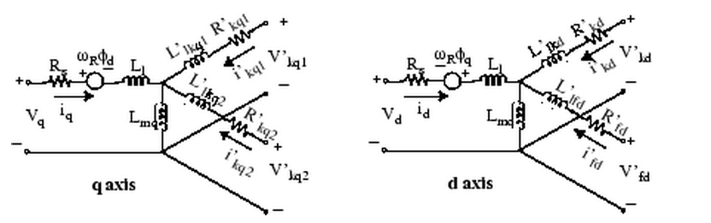 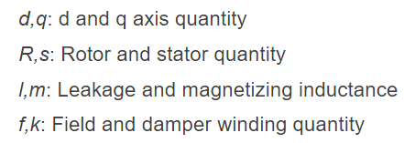

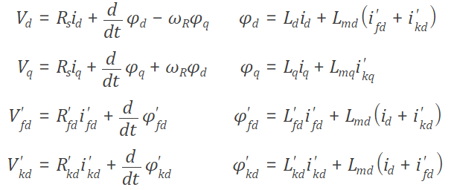

Voltage controller Model:

Frequency Controller model :